HTML
TUGAS 1 : JUDUL SEUAI DENGAN MODUL
Nama /Nim | : | Andra Syailendra Perdana / 2318901
Kelas | : | A
Pengajar | : | BUDI PRIYONGGO(2518026)

Tujuan
- Praktikan mampu memahami struktur dasar CSS
- Praktikan mampu memahami dasar – dasar CSS
- Praktikan dapat menghubungkan antara HTML dengan CSS untuk membuat halaman Web yang responsif.

Alat dan Bahan
- Laptop/pc
- Modul Praktikum Web 2026
- TextEditor (Visual Studio Code / Sublime Text)

Langkah-langkah
- Buat file style.css dan letakkan dalam folder css yang telah dibuat.
Source Code :
* {
margin: 0;
padding: 0;
box-sizing: border-box;
}

.container {
width: 80%;
margin: 0 auto;
}

body {
font-family: "Poppins", sans-serif;
}

/* new nav */
nav {
display: flex;
height: 80px;
width: 100%;
align-items: center;
justify-content: space-between;
flex-wrap: wrap;
}
nav ul {
display: flex;
flex-wrap: wrap;
list-style: none;
}
nav ul li {
margin: 0 5px;
}
nav ul li a {
color: #111;
text-decoration: none;
font-weight: 500;
padding: 8px 15px;
transition: all 0.3s ease;
}
nav ul li a.active,
nav ul li a:hover {
color: #ffb72b;
}
nav .menu-btn i {
color: #000;
font-size: 22px;
cursor: pointer;
display: none;
}
input[type="checkbox"] {
display: none;
}

.btn_login {
background-color: #ffb72b;
width: 100%;
padding: 8px 16px;
border-radius: 10px;
border: none;
cursor: pointer;
color: white;
}

.btn_login:hover {
background-color: #eba416;
color: #fff;
}

/* style jumbotron */
.jumbotron {
display: flex;
background-color: #ffb72b;
border-radius: 20px;
padding: 20px 0;
justify-content: space-around;
align-items: center;
margin-bottom: 50px;
}

.jumbotron-text {
width: 30%;
font-weight: 500;
}

.jumbotron-text p {
color: white;
margin: 20px 0;
}

.jumbotron-text button {
padding: 10px 18px;
border: none;
border-radius: 10px;
background-color: white;
color: #ffb72b;
cursor: pointer;
}

/* style card-categories */
.cards-categories {
display: flex;
flex-direction: column;
align-items: center;
}

.cards-categories h2 {
font-family: "Roboto", sans-serif;
font-size: 24px;
margin-bottom: 20px;
text-align: center;
}

.card-categories {
display: grid;
gap: 1.5rem;
grid-template-columns: repeat(auto-fit, minmax(20rem, 1fr));
}

.card {
box-shadow: 0 10px 20px rgba(0, 0, 0, 0.1);
border-radius: 15px;
overflow: hidden;
transition: transform 0.3s ease-in-out;
}

.card:hover {
transform: scale(1.05);
}

.card .card-image {
overflow: hidden;
border-radius: 15px 15px 0 0;
}

.card img {
width: 100%;
height: auto;
object-fit: cover;
border-radius: 15px 15px 0 0;
}

.card-content {
padding: 20px;
}

.card h5 {
margin-bottom: 10px;
font-family: "Roboto", sans-serif;
font-size: 22px;
font-weight: 600;
color: #333;
}

.card p.description {
font-size: 14px;
color: #666;
margin-bottom: 15px;
}

.card p.price {
font-size: 18px;
font-weight: bold;
color: #ffb72b;
margin-bottom: 15px;
}

.card .btn_belanja {
background-color: #ffb72b;
padding: 12px 20px;
border-radius: 8px;
border: none;
cursor: pointer;
color: white;
font-size: 16px;
transition: background-color 0.3s ease;
}

.card .btn_belanja:hover {
background-color: #eba416;
}

/* footer */
footer {
display: flex;
justify-content: center;
align-items: center;
margin: 40px 0;
}

/* responsive */
@media screen and (max-width: 1023px) {
.container {
width: 100%;
margin: 0 auto;
}
/* navbar responsive */
nav {
padding: 0 40px 0 50px;
position: relative;
}

nav .menu-btn i {
display: block;
}
#click:checked ~ .menu-btn i:before {
content: "\f00d";
}
nav ul {
position: absolute;
top: 80px;
left: -100%;
background: rgba(0, 0, 0, 0.85);
width: 100%;
text-align: center;
display: block;
transition: all 0.3s ease;
}
#click:checked ~ ul {
left: 0;
}
nav ul li {
width: 100%;
margin: 40px 0;
}
nav ul li a {
width: 100%;
margin-left: -100%;
display: block;
font-size: 20px;
color: #fff;
transition: 0.6s cubic-bezier(0.68, -0.55, 0.265, 1.55);
}
#click:checked ~ ul li a {
margin-left: 0px;
}
nav ul li a.active,
nav ul li a:hover {
color: #ffb72b;
}

/* jumbotron responsive */
.jumbotron {
flex-direction: column-reverse;
border-radius: 0px !important;
justify-content: center;
}
.jumbotron-img img {
width: 100% !important;
}

.jumbotron-text {
width: 100% !important;
padding-left: 20px;
}

/* card-categories responsive */
.card-categories {
flex-direction: column;
gap: 20px;
margin: 0 10px;
}

.card {
width: 100% !important;
}
}
- Ubah file index.html
Source Code :
<!DOCTYPE html>
<html lang="en">
<head>
<link rel="icon" href="assets/icon.png" />
<title>Home</title>
<link rel="stylesheet" href="css/style.css" />
<link rel="preconnect" href="https://fonts.googleapis.com" />
<link rel="preconnect" href="https://fonts.gstatic.com" crossorigin />
<link href="https://fonts.googleapis.com/css2?family=Poppins:wght@400;500;700&family=Roboto:wght@500;700&display=swap" rel="stylesheet" />
<link rel="stylesheet" href="https://cdnjs.cloudflare.com/ajax/libs/font-awesome/5.15.3/css/all.min.css" />
</head>
<body>
<div class="container">
<header>
<nav>
<div class="logo">
<img src="assets/logo.png" alt="" />
</div>
<input type="checkbox" id="click" />
<label for="click" class="menu-btn">
<i class="fas fa-bars"></i>
</label>
<ul>
<li><a href="#">Home</a></li>
<li><a href="#">Categories</a></li>
<li><a href="login.html" class="btn_login">Login</a></li>
</ul>
</nav>
</header>
<main>
<div class="jumbotron">
<div class="jumbotron-text">
<h1>Find Your New Little Cat, Make a New Friend</h1>
<p>Teman barumu yang lucu menunggu mu, ayo temukan mereka sekarang</p>
<button type="button" class="btn_getStarted">Get Started</button>
</div>
<div class="jumbotron-img">
<img src="assets/jumbotron.png" alt="" />
</div>
</div>
<div class="cards-categories">
<h2>Cat Categories</h2>
<div class="card-categories">
<div class="card">
<div class="card-image">
<img src="assets/anggora.png" alt="gambar tidak ditemukan" />
</div>
<div class="card-content">
<h5>Anggora</h5>
<p class="description">Anggora turki adalah salah satu ras kucing domestik alami tertua. Ras ini berasal dari Ankara, Turki.</p>
<p class="price"><span>Rp.</span>50,000</p>
<button class="btn_belanja" type="submit">Beli</button>
</div>
</div>
<!-- Card Persia & British Shorthair disembunyikan untuk menyingkat kode laporan -->
</div>
</div>
</main>
<footer>
<h4>&copy; Lab Pemrograman Komputer 2026</h4>
</footer>
</div>
</body>
</html>
Hasil Tampilan :
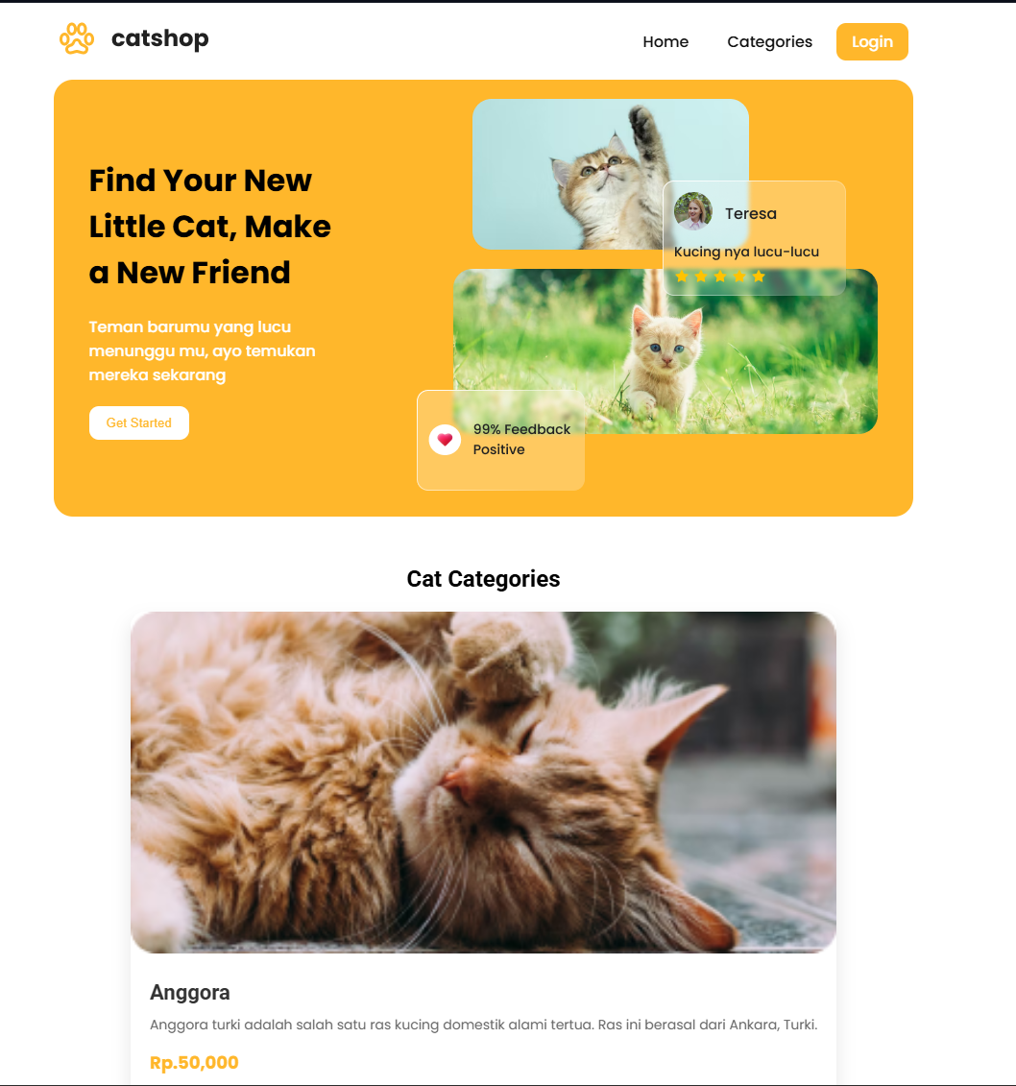

1.1 Tampilan Index/frontpage
- Ubah file login.html
Source Code :
<!DOCTYPE html>
<html lang="en">
<head>
<title>Login</title>
<link rel="icon" href="assets/icon.png" />
<link rel="stylesheet" href="css/style.css" />
<link rel="preconnect" href="https://fonts.googleapis.com" />
<link rel="preconnect" href="https://fonts.gstatic.com" crossorigin />
<link href="https://fonts.googleapis.com/css2?family=Poppins:wght@400;500;700&family=Roboto:wght@500;700&display=swap" rel="stylesheet" />
<link rel="stylesheet" href="https://cdnjs.cloudflare.com/ajax/libs/font-awesome/5.15.3/css/all.min.css" />
</head>
<body>
<div class="container">
<header>
<nav>
<div class="logo"><img src="assets/logo.png" alt="" /></div>
<input type="checkbox" id="click" />
<label for="click" class="menu-btn"><i class="fas fa-bars"></i></label>
<ul>
<li><a href="index.html">Home</a></li>
<li><a href="#">Categories</a></li>
<li><a href="login.html" class="btn_login">Login</a></li>
</ul>
</nav>
</header>
<main>
<div class="center">
<div class="form-login">
<h3>Login</h3>
<form action="">
<input class="input" type="text" name="username" placeholder="Username" />
<input class="input" type="password" name="password" placeholder="Password" />
<button type="submit" class="btn_login" name="login" id="login">Login</button>
</form>
<a href="register.html" class="link-register"> Register Disini</a>
</div>
</div>
</main>
<footer>
<h4>&copy; Lab Pemrograman Komputer 2026</h4>
</footer>
</div>
</body>
</html>

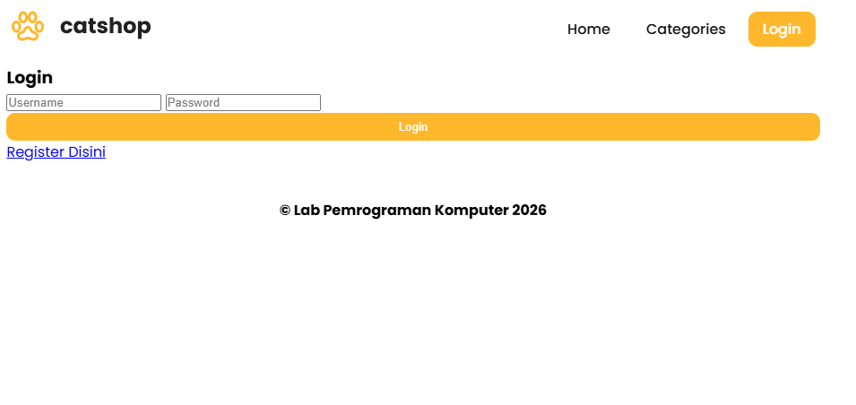

1.2 Tampilan Login

- Ubah isi dari file register.html
Source Code :
<!DOCTYPE html>
<html lang="en">
<head>
<title>Register</title>
<link rel="icon" href="assets/icon.png" />
<link rel="stylesheet" href="css/style.css" />
<link rel="preconnect" href="https://fonts.googleapis.com" />
<link rel="preconnect" href="https://fonts.gstatic.com" crossorigin />
<link href="https://fonts.googleapis.com/css2?family=Poppins:wght@400;500;700&family=Roboto:wght@500;700&display=swap" rel="stylesheet" />
<link rel="stylesheet" href="https://cdnjs.cloudflare.com/ajax/libs/font-awesome/5.15.3/css/all.min.css" />
</head>
<body>
<div class="container">
<header>
<nav>
<div class="logo"><img src="assets/logo.png" alt="" /></div>
<input type="checkbox" id="click" />
<label for="click" class="menu-btn"><i class="fas fa-bars"></i></label>
<ul>
<li><a href="index.html">Home</a></li>
<li><a href="#">Categories</a></li>
<li><a href="login.html" class="btn_login">Login</a></li>
</ul>
</nav>
</header>
<main>
<div class="center">
<div class="form-login">
<h3>Register</h3>
<form action="">
<input class="input" type="email" name="email" placeholder="Email" />
<input class="input" type="text" name="username" placeholder="Username" />
<input class="input" type="password" name="password" placeholder="Password" />
<button type="submit" class="btn_login" name="register" id="register">Register</button>
</form>
</div>
</div>
</main>
<footer>
<h4>&copy; Lab Pemrograman Komputer 2026</h4>
</footer>
</div>
</body>
</html>

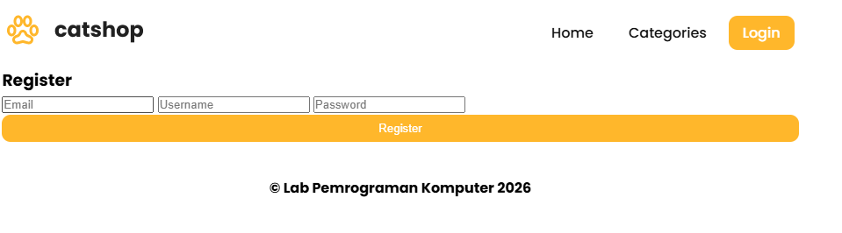

1.3 Tampilan Register
- Buat file style.css dan letakkan dalam folder css yang telah dibuat.
Source Code :
@import url("https://fonts.googleapis.com/css2?family=Poppins:wght@200;300;400;500;600;700&display=swap");
* { margin: 0; padding: 0; box-sizing: border-box; font-family: "Poppins", sans-serif; }
.sidebar { position: fixed; height: 100%; width: 240px; background: #ffb72b; transition: all 0.5s ease; }
.sidebar.active { width: 60px; }
.sidebar .logo-details { height: 80px; display: flex; align-items: center; }
.sidebar .logo-details i { font-size: 28px; font-weight: 500; color: #fff; min-width: 60px; text-align: center; }
.sidebar .logo-details .logo_name { color: #fff; font-size: 24px; font-weight: 500; }
.sidebar .nav-links { margin-top: 10px; }
.sidebar .nav-links li { position: relative; list-style: none; height: 50px; }
.sidebar .nav-links li a { height: 100%; width: 100%; display: flex; align-items: center; text-decoration: none; transition: all 0.4s ease; }
.sidebar .nav-links li a.active, .sidebar .nav-links li a:hover { background: #eba416; }
.sidebar .nav-links li i { min-width: 60px; text-align: center; font-size: 18px; color: #fff; }
.sidebar .nav-links li a .links_name { color: #fff; font-size: 15px; font-weight: 400; white-space: nowrap; }
.home-section { position: relative; background: #f5f5f5; min-height: 100vh; width: calc(100% - 240px); left: 240px; transition: all 0.5s ease; }
.sidebar.active ~ .home-section { width: calc(100% - 60px); left: 60px; }
.home-section nav { display: flex; justify-content: space-between; height: 80px; background: #fff; align-items: center; position: fixed; width: calc(100% - 240px); left: 240px; z-index: 100; padding: 0 20px; box-shadow: 0 1px 1px rgba(0, 0, 0, 0.1); transition: all 0.5s ease; }
.sidebar.active ~ .home-section nav { left: 60px; width: calc(100% - 60px); }
.home-section nav .sidebar-button { display: flex; align-items: center; font-size: 24px; font-weight: 500; }
nav .sidebar-button i { font-size: 35px; margin-right: 10px; }
.home-section nav .profile-details { display: flex; align-items: center; justify-content: center; background: #f5f6fa; border: 2px solid #efeef1; border-radius: 6px; height: 50px; min-width: 190px; }
nav .profile-details .admin_name { font-size: 15px; font-weight: 500; color: #333; white-space: nowrap; }
.home-section .home-content { position: relative; padding-top: 104px; padding-left: 20px; padding-right: 20px; }
.btn { background-color: #ffb72b; color: white; padding: 10px 20px; border: none; border-radius: 5px; cursor: pointer; }
.btn a { text-decoration: none; color: white; }
.btn-tambah { margin: 10px 0; }
.btn-simpan { width: 100%; }
.btn:hover { background-color: #eba416; }
.table-data { text-align: center; border-collapse: collapse; width: 100%; overflow-x: auto; }
th, td { border: 1px solid black; padding: 5px 20px; }
.btn-edit, .btn-delete { padding: 8px 16px; margin-right: 8px; border: none; border-radius: 4px; cursor: pointer; font-size: 14px; }
.btn-edit { background-color: #4caf50; color: white; }
.btn-delete { background-color: #f44336; color: white; }
.form-login { display: flex; flex-direction: column; align-items: center; background-color: white; padding: 30px; margin: 10px auto; border-radius: 10px; }
.input { width: 100%; margin: 10px 0; padding: 10px; border-radius: 10px; border: 1px solid rgb(148, 148, 148); }
.success { background-color: #4CAF50; color: white; border-radius: 5px; padding: 5px 10px; }
.btn_detail { background-color: #2196F3; color: white; padding: 5px 10px; border-radius: 5px; border: none; }
@media (max-width: 1240px) { .sidebar { width: 60px; } .sidebar.active { width: 220px; } .home-section { width: calc(100% - 60px); left: 60px; } .sidebar.active ~ .home-section { overflow: hidden; left: 220px; } .home-section nav { width: calc(100% - 60px); left: 60px; } .sidebar.active ~ .home-section nav { width: calc(100% - 220px); left: 220px; } }
@media (max-width: 700px) { nav .profile-details { display: none !important; } }
@media (max-width: 400px) { .sidebar { width: 0; } .sidebar.active { width: 60px; } .home-section, .home-section nav { width: 100%; left: 0; } .sidebar.active ~ .home-section, .sidebar.active ~ .home-section nav { left: 60px; width: calc(100% - 60px); } }

- Buat file baru dengan nama admin.html
Source Code :
<!DOCTYPE html>
<html lang="en">
<head>
<meta charset="UTF-8" />
<link rel="icon" href="assets/icon.png" />
<link rel="stylesheet" href="css/admin.css" />
<link href="https://unpkg.com/boxicons@2.0.7/css/boxicons.min.css" rel="stylesheet" />
<meta name="viewport" content="width=device-width, initial-scale=1.0" />
<title>Catshop Admin</title>
</head>
<body>
<div class="sidebar">
<div class="logo-details">
<i class="bx bx-category"></i>
<span class="logo_name">CatShop</span>
</div>
<ul class="nav-links">
<li><a href="#" class="active"><i class="bx bx-grid-alt"></i><span class="links_name">Dashboard</span></a></li>
<li><a href="categories/categories.html"><i class="bx bx-box"></i><span class="links_name">Categories</span></a></li>
<li><a href="transaction/transaction.html"><i class="bx bx-list-ul"></i><span class="links_name">Transaction</span></a></li>
</ul>
</div>
<section class="home-section">
<nav>
<div class="sidebar-button"><i class="bx bx-menu sidebarBtn"></i></div>
<div class="profile-details"><span class="admin_name">Catshop Admin</span></div>
</nav>
<div class="home-content">
<h1>Selamat Datang Admin</h1>
</div>
</section>
<script>
let sidebar = document.querySelector(".sidebar");
let sidebarBtn = document.querySelector(".sidebarBtn");
sidebarBtn.onclick = function () {
sidebar.classList.toggle("active");
if (sidebar.classList.contains("active")) {
sidebarBtn.classList.replace("bx-menu", "bx-menu-alt-right");
} else sidebarBtn.classList.replace("bx-menu-alt-right", "bx-menu");
};
</script>
</body>
</html>

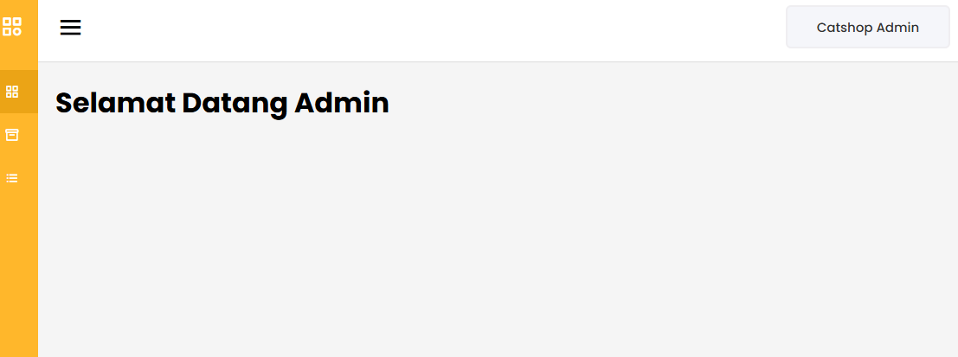

1.4 Tampilan Halaman Admin
- Buat file categories.html di folder categories
Source Code :
<!DOCTYPE html>
<html lang="en" dir="ltr">
<head>
<meta charset="UTF-8" />
<link rel="stylesheet" href="../css/admin.css" />
<link href="https://unpkg.com/boxicons@2.0.7/css/boxicons.min.css" rel="stylesheet" />
<title>Categories</title>
</head>
<body>
<div class="sidebar">
<div class="logo-details"><i class="bx bx-category"></i><span class="logo_name">CatShop</span></div>
<ul class="nav-links">
<li><a href="../admin.html"><i class="bx bx-grid-alt"></i><span class="links_name">Dashboard</span></a></li>
<li><a href="../categories/categories.html" class="active"><i class="bx bx-box"></i><span class="links_name">Categories</span></a></li>
</ul>
</div>
<section class="home-section">
<nav>
<div class="sidebar-button"><i class="bx bx-menu sidebarBtn"></i></div>
<div class="profile-details"><span class="admin_name">Catshop Admin</span></div>
</nav>
<div class="home-content">
<h3>Categories</h3>
<button type="button" class="btn btn-tambah"><a href="categories-entry.html">Tambah Data</a></button>
<table class="table-data">
<thead>
<tr><th>Photo</th><th>Categories</th><th>Description</th><th>Price</th><th>Action</th></tr>
</thead>
<tbody>
<tr>
<td><img src="../assets/thumbnail/anggora.png" alt="" /></td>
<td>Anggora</td>
<td>Anggora turki adalah salah satu ras kucing domestik alami tertua.</td>
<td>450,000</td>
<td><button class="btn-edit">Edit</button> <button class="btn-delete">Hapus</button></td>
</tr>
</tbody>
</table>
</div>
</section>
</body>
</html>

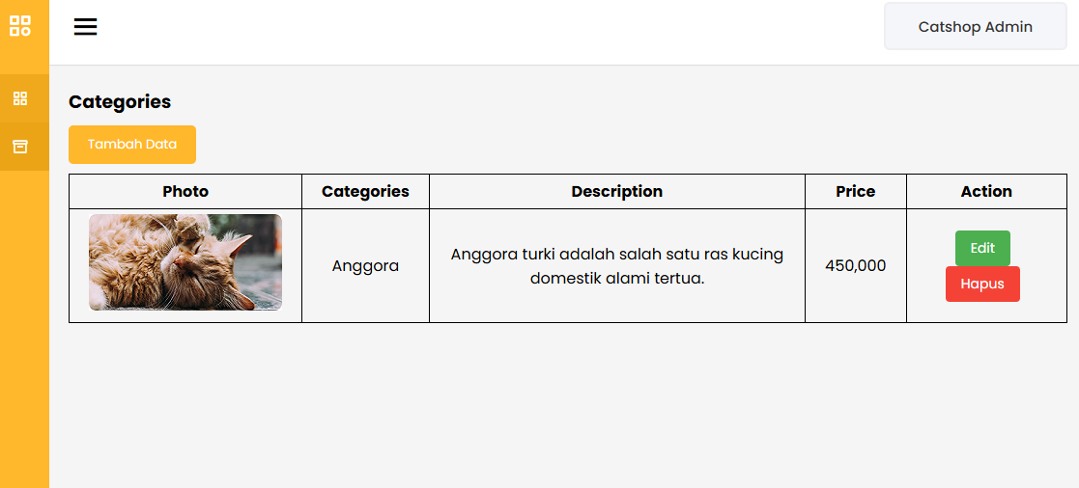

1.5 Tampilan Halaman Categories
- Buat file categories-entry.html di folder categories
Source Code :
<!DOCTYPE html>
<html lang="en" dir="ltr">
<head>
<meta charset="UTF-8" />
<link rel="stylesheet" href="../css/admin.css" />
<title>Categories Entry</title>
</head>
<body>
<section class="home-section" style="width: 100%; left: 0;">
<div class="home-content">
<h3>Input Categories</h3>
<div class="form-login">
<form action="">
<label>Categories</label>
<input class="input" type="text" placeholder="Categories" />
<label>Price</label>
<input class="input" type="text" placeholder="Price" />
<label>Description</label>
<input class="input" type="text" placeholder="Description" />
<label>Photo</label>
<input type="file" style="margin-bottom: 20px" />
<button type="submit" class="btn btn-simpan">Simpan</button>
</form>
</div>
</div>
</section>
</body>
</html>

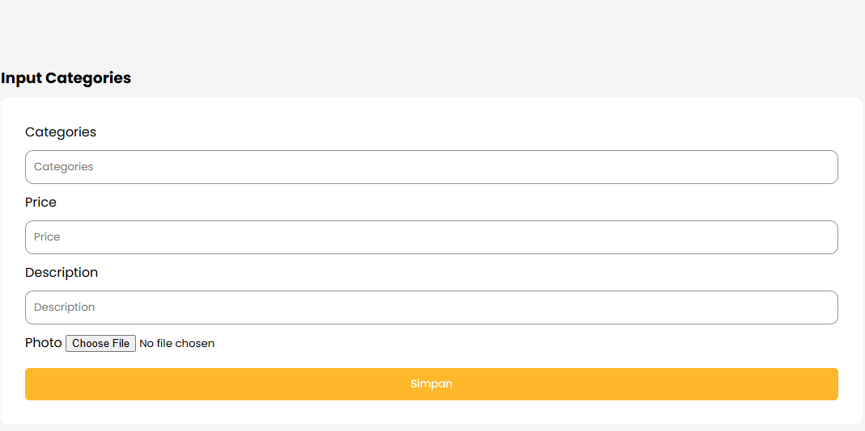

1.6 Tampilan Halaman Categories
- Buat file transaction.html di folder transaction
Source Code :
<!DOCTYPE html>
<html lang="en">
<head>
<meta charset="UTF-8" />
<link rel="stylesheet" href="../css/admin.css" />
<link href="https://unpkg.com/boxicons@2.0.7/css/boxicons.min.css" rel="stylesheet" />
<title>Transaction</title>
</head>
<body>
<div class="sidebar">
<div class="logo-details"><i class="bx bx-category"></i><span class="logo_name">CatShop</span></div>
<ul class="nav-links">
<li><a href="../admin.html"><i class="bx bx-grid-alt"></i><span class="links_name">Dashboard</span></a></li>
<li><a href="transaction.html" class="active"><i class="bx bx-list-ul"></i><span class="links_name">Transaction</span></a></li>
</ul>
</div>
<section class="home-section">
<nav>
<div class="sidebar-button"><i class="bx bx-menu sidebarBtn"></i></div>
<div class="profile-details"><span class="admin_name">Catshop Admin</span></div>
</nav>
<div class="home-content">
<h3>Transaction</h3>
<table class="table-data">
<thead>
<tr><th>Tanggal</th><th>Nama</th><th>Kategori</th><th>Harga</th><th>Status</th><th>Action</th></tr>
</thead>
<tbody>
<tr>
<td>02-03-2023</td>
<td>Raflizar</td>
<td>Anggora</td>
<td>450000</td>
<td><p class="success">Success</p></td>
<td><button class="btn_detail">Detail</button></td>
</tr>
</tbody>
</table>
</div>
</section>
</body>
</html>

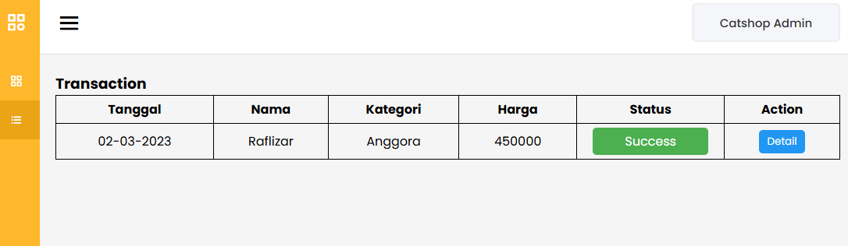

1.7 Tampilan Halaman Transaction

Analisa :
Berdasarkan praktikum dari Project CatShop secara utuh, dapat dianalisis bahwa CSS memiliki peran yang sangat signifikan dalam merancang User Interface (UI) dari sistem yang terstruktur. Pada bagian antarmuka publik (index.html), penataan elemen (layouting) menggunakan Flexible Box Model (Flexbox) dan Grid membuat penempatan gambar serta katalog produk menjadi simetris dan mudah disesuaikan menggunakan Media Query agar responsif di ukuran layar kecil. Pada bagian antarmuka sistem operasi/Admin (admin.html), implementasi CSS digunakan untuk memisahkan struktur navigasi (Sidebar) di sisi kiri yang bersifat statis (position: fixed;) dengan area kerja (Main Content) di sisi kanan (width: calc(100% - 240px);). Penggunaan transisi animasi (transition: all 0.5s ease;) saat menyembunyikan dan memunculkan sidebar menggunakan JavaScript juga memberikan User Experience (UX) yang sangat dinamis layaknya aplikasi modern

